Prerequisite IBM Cloud Service

|  |  |
| --- | --- |
| Date | 29 October 2022 |
| Team ID | PNT2022TMID33811 |
| Project Name | Project – Smart Farmer-IoT Enabled smart Farming Application |
| Maximum Marks | 4 Marks |

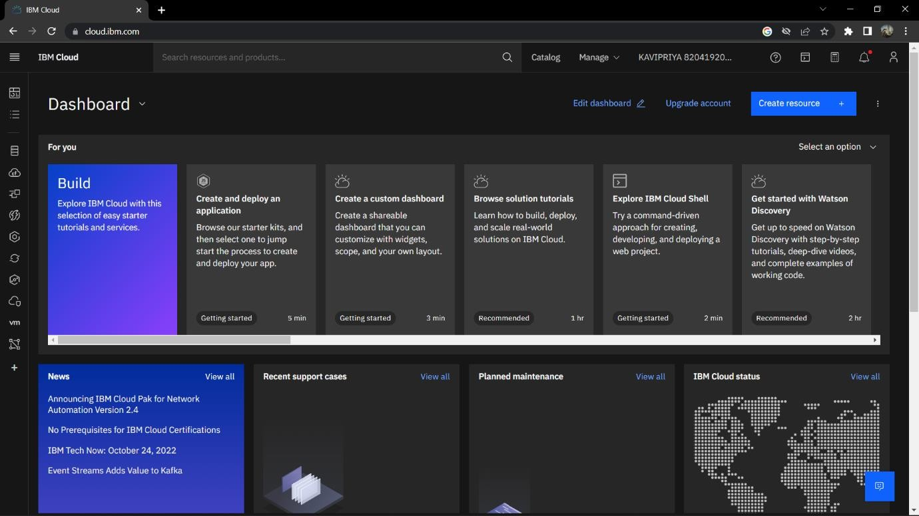IBM Account Dashboard

IBM Watson IoT Platform

